|  |
| --- |
| **Team ID :** LTVIP2025TMID57320 |
| **Project Name :** OrderOnTheGo: Your On-Demand Food Ordering Solution |

**Project Implementation & Execution**

**Landing page**

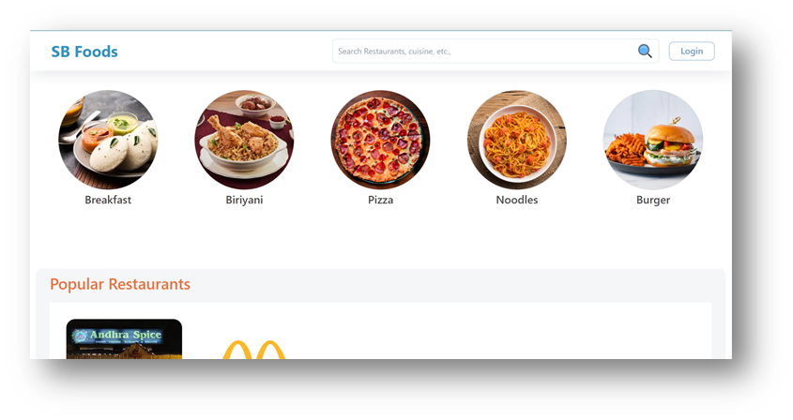

·       **Restaurants**

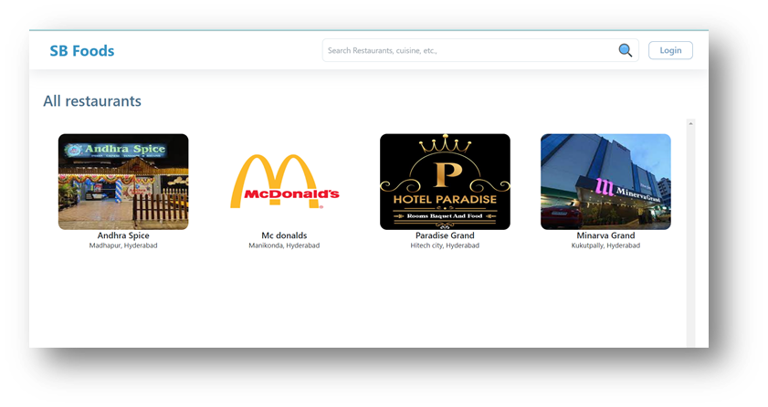

·       **Restaurant Menu**

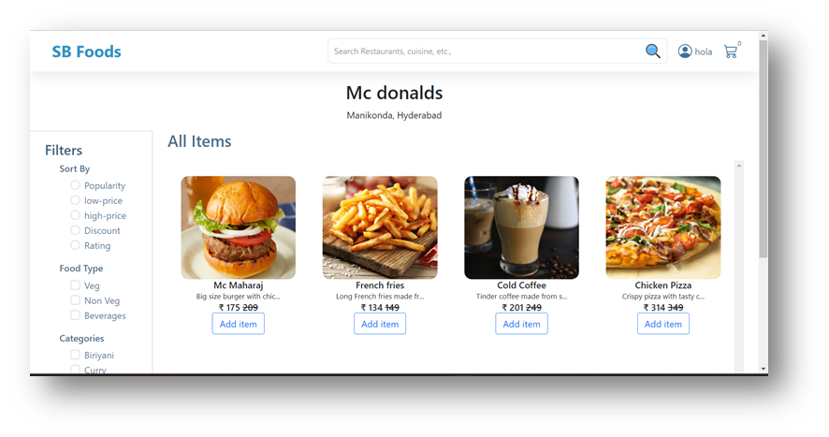

·       **Authentication**

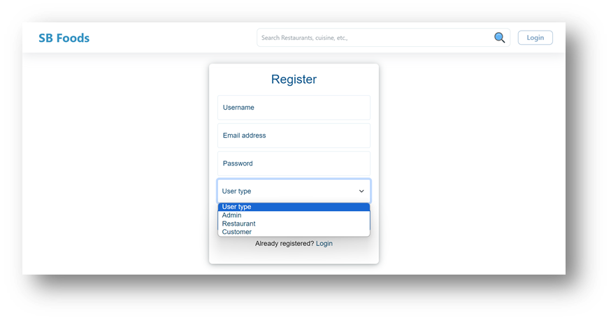

·       **User Profile**

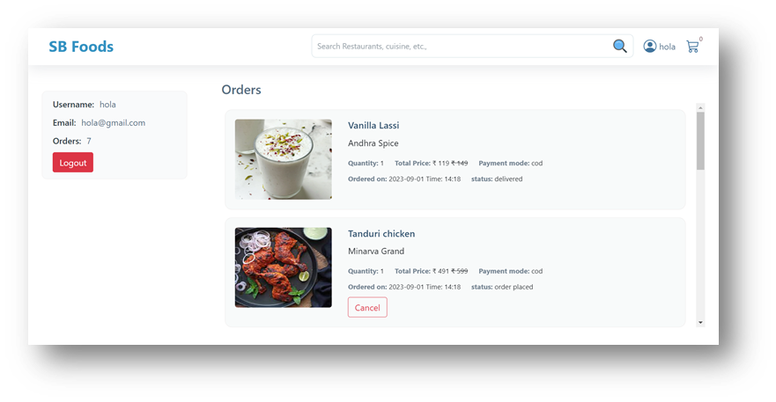

**·       Cart**

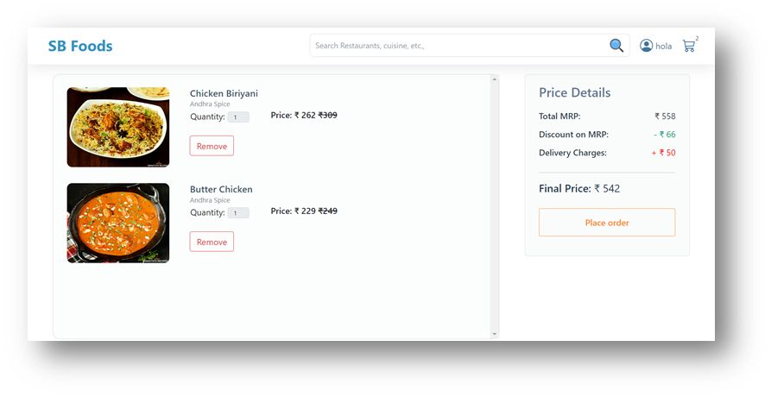

**·       Admin dashboard**

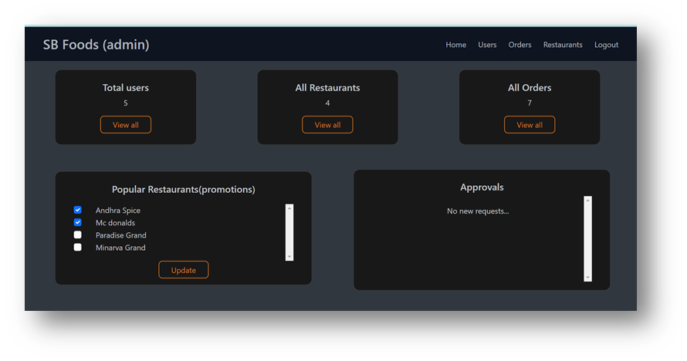

**·       All Orders**

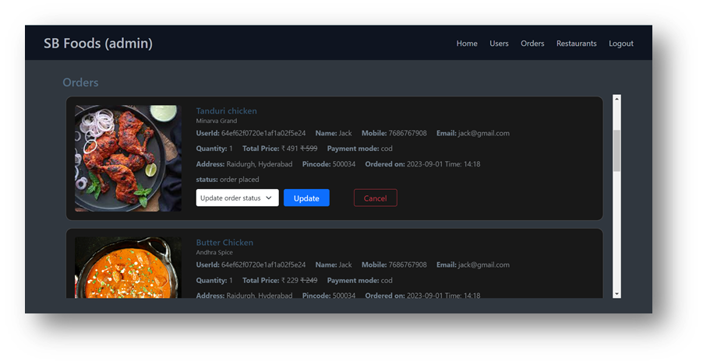

**·       All restaurants**

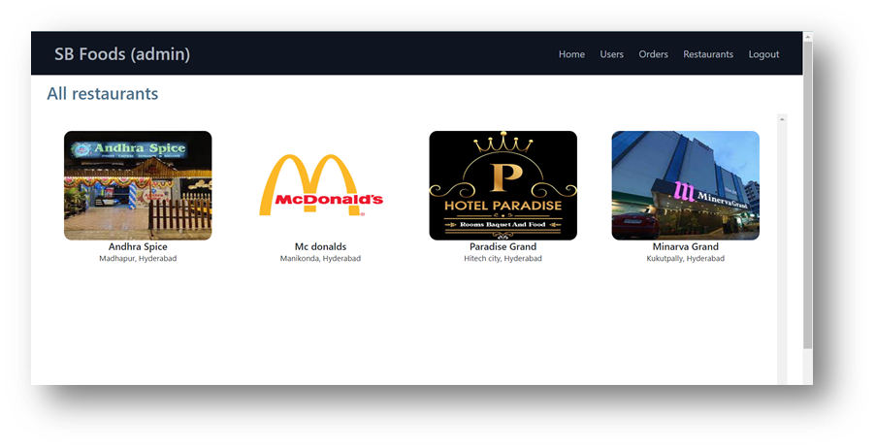

**·       Restaurant Dashboard**

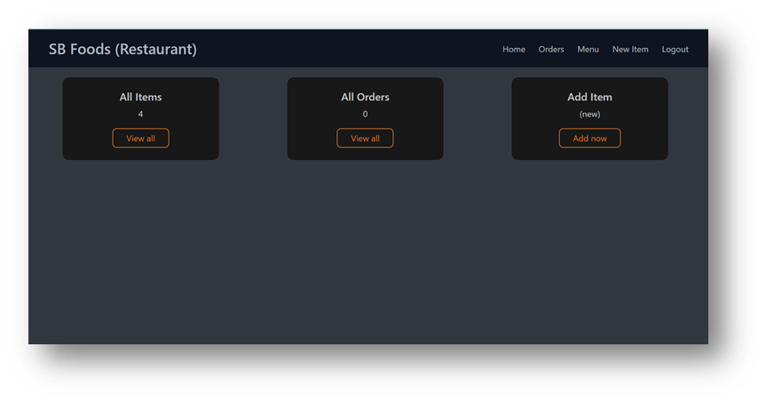

**·       New Item**

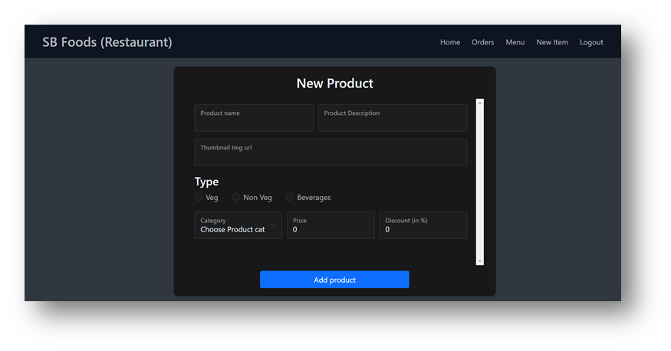

Demo Video : <https://drive.google.com/file/d/1cTS3_-EOAAvDctkibG5zVikrTdmoY2Ag/view?usp=sharing>